Project Demonstration
Screenshots
Date | 12 July 2026
Team ID | SWTID-2026-4644
Project Name | Smart Lender
Phase | 8. Project Demonstration

Purpose — Fallback Visual Aid
If a live demo isn't possible (no network access, environment issue, time constraints), these genuine screenshots — reused unmodified from the Project Testing phase — let the presenter narrate the same Demo_Script.docx steps using real captured evidence instead of a live session.
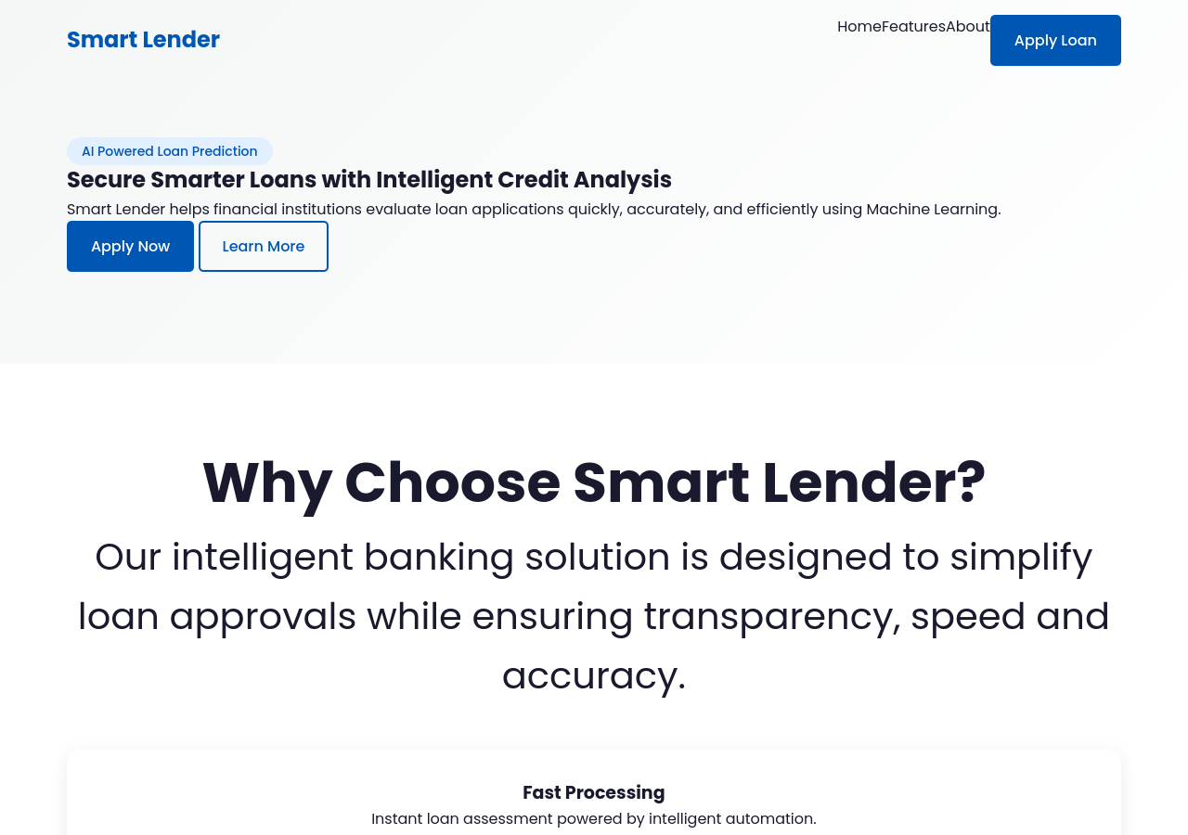
Figure 1: Home page (fallback visual for Demo_Script.docx step 1).
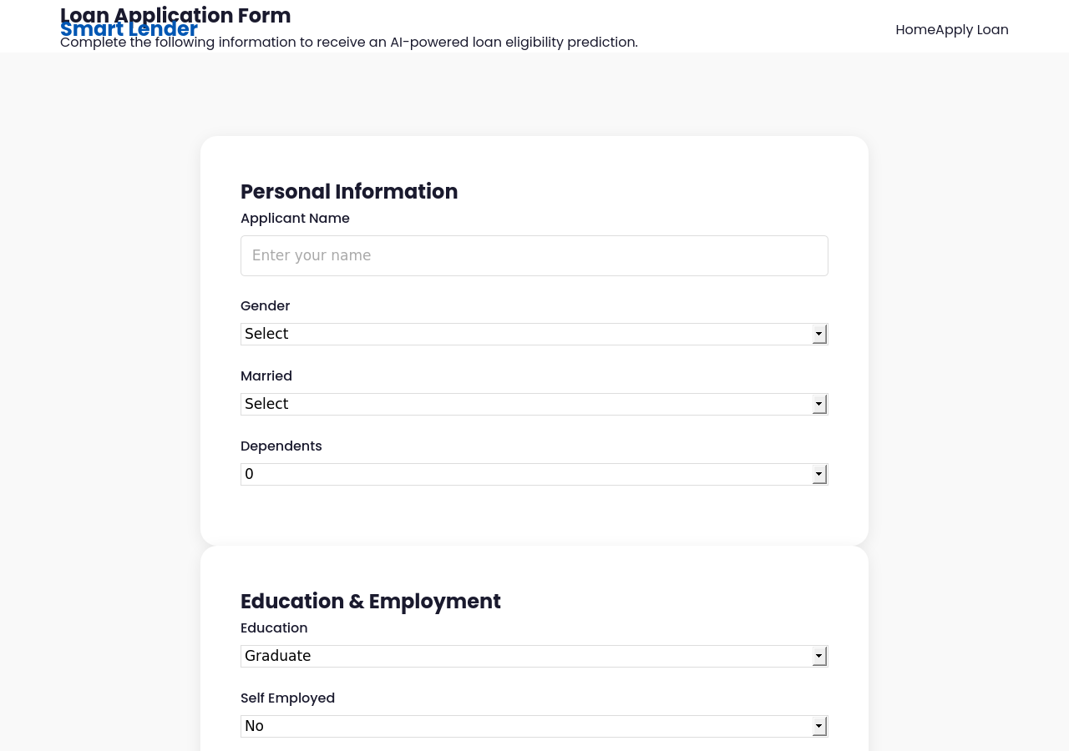
Figure 2: Loan application form (fallback visual for Demo_Script.docx step 2).
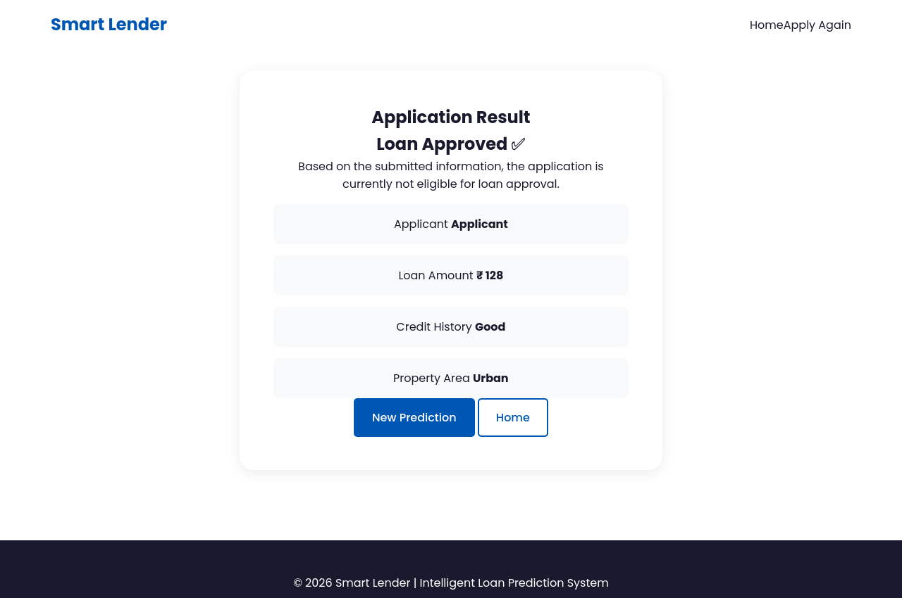
Figure 3: Approved result (fallback visual for Demo_Script.docx steps 3–4).
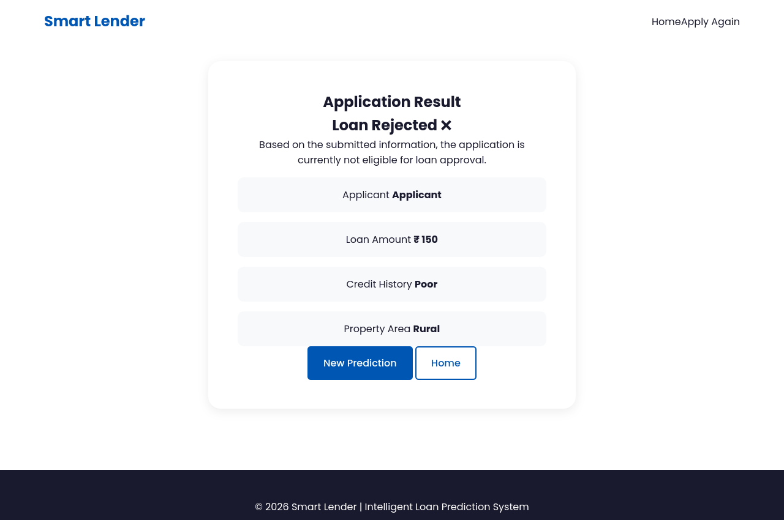
Figure 4: Rejected result (fallback visual for Demo_Script.docx steps 5–6).

Provenance
All four images are unmodified copies of the genuine, live-application captures first produced during the Project Testing phase (see that phase's Screenshot_Provenance.md for the exact capture method). No new screenshots were generated for this phase, and none were fabricated or staged.

